QUIZ Advanced Design Applications
Write down the measurement as specified
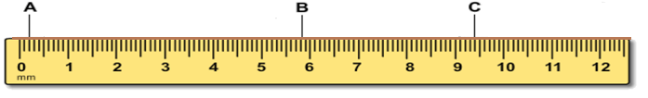
A 2 mm B 5.8 cm C 94 mm example
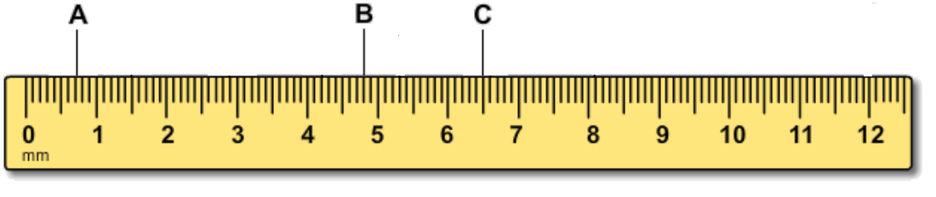
A ______________________________________ mm
B _________________________ cm
C _____________________ mm
Copy each joint and its name
biscuit 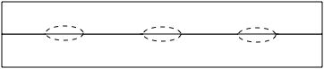
dovetail 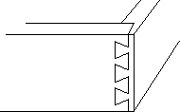
dado
lap 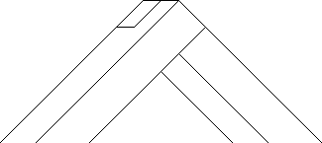
miter 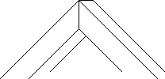

spline 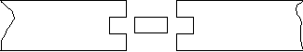

Read this information then Fill in the blanks: Choose from these materials: steel, concrete, wood, particleboard
Steel is one of the strongest building materials but it is expensive. It is strong in tension and compression. Unfortunately, it can melt at high temperatures.
Concrete is strong in compression and is fireproof. It is not too expensive but it is very heavy and it is not flexible. Buildings made of all concrete can easily fall apart in an earthquake if you do not add flexible parts.
Wood is strong in tension and can bend a little but it is very hard to create curved parts from wood. Wood must be painted with some sort of protectant seal or it will decompose much faster than any of the other materials here. It is good because it is a renewable resource, but a big disadvantage is how easily it burns like in the Great Chicago fire of the 1800’s that burned most of the city down over 3 days.
Particle board is very inexpensive mostly because it is made out of scraps used in wood working. The scraps are held together with a special glue that is also bug-proof and rot-proof, but it is not water-proof and after a few years it can swell and sag especially if it’s in a place with a lot of moisture. It is not practical for outside building like steel, concrete and wood are.

Fill in the blanks: Choose from these materials: steel, concrete, wood, particleboard
What is the least cost material that can be made out of all recycled materials? ____________
What is strong in both tension and compression? ____________
What requires finishing and is strong in tension? __________________
What sags over time and absorbs moisture faster than other materials? _____________________
What can withstand fire and is strong in compression? ____________

QUIZ Advanced Design Applications
A 2 mm B 5.8 cm C 94 mm example
Write down the measurement as specified
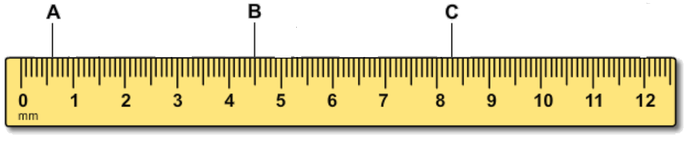
A ______________________________________ mm
B _________________________ cm
C _____________________ mm
Copy each joint and its name
biscuit
dovetail
dado
lap
miter

spline

Read this information then Fill in the blanks: Choose from these materials: steel, concrete, wood, particleboard
Steel is one of the strongest building materials but it is expensive. It is strong in tension and compression. Unfortunately, it can melt at high temperatures.
Concrete is strong in compression and is fireproof. It is not too expensive but it is very heavy and it is not flexible. Buildings made of all concrete can easily fall apart in an earthquake if you do not add flexible parts.
Wood is strong in tension and can bend a little but it is very hard to create curved parts from wood. Wood must be painted with some sort of protectant seal or it will decompose much faster than any of the other materials here. It is good because it is a renewable resource, but a big disadvantage is how easily it burns like in the Great Chicago fire of the 1800’s that burned most of the city down over 3 days.
Particle board is very inexpensive mostly because it is made out of scraps used in wood working. The scraps are held together with a special glue that is also bug-proof and rot-proof, but it is not water-proof and after a few years it can swell and sag especially if it’s in a place with a lot of moisture. It is not practical for outside building like steel, concrete and wood are.

Fill in the blanks: Choose from these materials: steel, concrete, wood, particleboard
What sags over time and absorbs moisture faster than other materials? _____________________
What requires finishing and is strong in tension? __________________
What is strong in both tension and compression? ____________
What can withstand fire and is strong in compression? ____________
What is the least cost material that can be made out of all recycled materials? ____________

